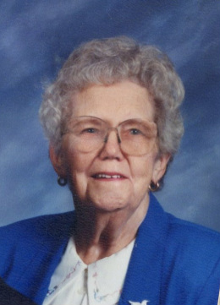
Elizabeth Albright Education Scholarship
In celebration of the Marlington Alumni Association's 25th Anniversary and as part of the Cultivating Great Minds campaign, in 2013 the seven children and extended families of Elizabeth Albright established the Elizabeth Albright Education Scholarship.
Honoring Elizabeth Albright’s eighteen years as a teacher at Lexington Elementary School, this scholarship is awarded to students pursuing a career in education.
The Albright family has a long history of hard work, community service and education. Sally (Albright) Rodgers is semi-retired as a Certified Public Accountant and lives in Canton, Ohio. Nancy (Albright) Shinn was a kindergarten teacher. She and her husband Larry reside in Berea, KY where he recently retired as president of Berea College. Kay (Albright) Burgi is a retired lab technician and preschool administrator. David Albright (’62) is a retired electrician and owner of Albright Electric in Alliance. Don Albright (’64) lives in Minerva and is retired after multiple careers in the area, and Carol (Albright) Mineweaser (’65) is a retired teacher and home health nurse. Mary (Albright) Swartz (’66) is retired after having worked as the Director of the University of Mount Union bookstore.
The seven children, fourteen grandchildren, thirty-seven great-grandchildren and three great-great grandchildren knew the best way to honor Elizabeth's love of family and her commitment to education was to help a Marlington graduate become a teacher.
Born in 1917, Mrs. Albright was a graduate of Alliance High School and Kent State University. She was a member of the Beechwood Christian Church, the Alliance Retired Teachers and a charter member of the Mended Hearts of Alliance. She was Past Matron of the Homeworth Eastern Stars, a volunteer for the Red Cross and a twenty year volunteer at Alliance Community Hospital. When not working or volunteering, Mrs. Albright always enjoyed cooking and sewing.

