Battershell Family Scholarship

Dating back to the early 1800’s, the Battershell family celebrates a long history with the region and Marlington schools. Family members settled in Lexington Township, establishing homes and farms, beginning small businesses and working in local factories and mills.
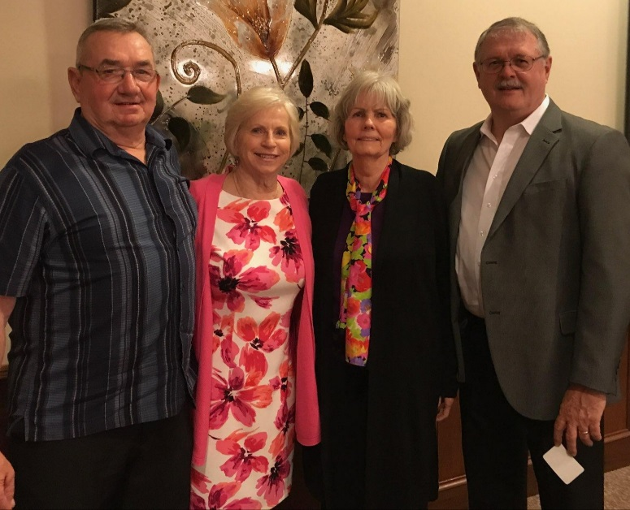
In 1956, Marlboro, Lexington, and Washington Township schools were consolidated to create the Marlington Local School District.

Since 1964 when the first Battershell graduated from Marlington, the family has enjoyed a rich history in the area. Serving as employees and teachers in the district, business owners, managers, blue collar workers, doctors and nurses throughout the region, the Battershell family is pleased to share their heritage and give back to their community.

The Battershell Family Scholarship supports a hardworking senior pursing any certificate or degree program. Priority is given to students considering Mechanical/Technical programs, Agriculture or Public Service/Safety (Police, Fire, etc.) Recipients will have a minimum GPA of 2.50 and will have participated in after school clubs, sports or any school sponsored activities.

