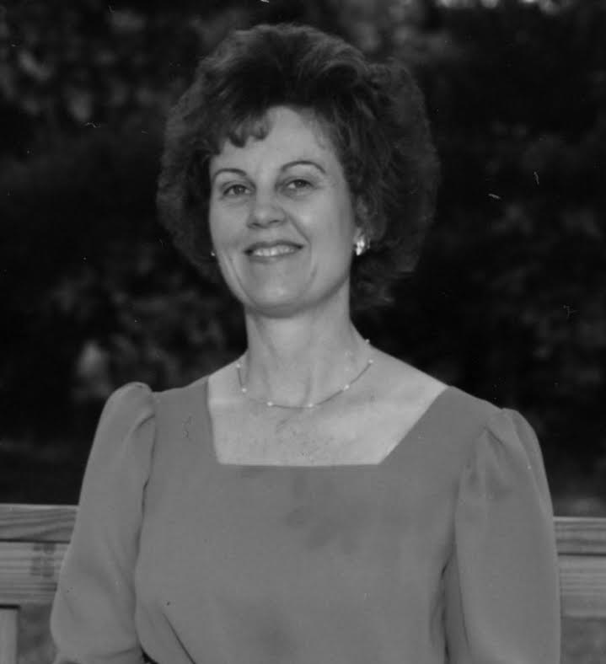
Mary Louise Bixler Education Scholarship
​The Mary Louise Bixler Education Scholarship was established December 2015 by her husband, Gerald, in honor of Mary’s love for children and education.
Mary (Anstine) Bixler (’58) graduated from Marlboro High School and studied Elementary Education at Kent State University and Malone College. Her teaching career began in the Louisville City Schools.
Mary married Marlboro graduate, Gerald, “Jerry” Bixler (‘56) in 1960. Together they raised two sons who graduated from Marlington High School, Brad in 1981 and Bruce in 1986.
Teaching in the district for more than 23 years, Mary taught kindergarten, first, second, third, and fifth grade at both Marlboro and Lexington Elementary Schools. She has always had a strong compassion for young children and a special sensitivity to their experiences. Knowing she could make a difference in the lives of her young learners, Mary tried to instill within her students a love for reading and learning.
In addition to teaching, Mary has always found time to be active in her church and community. While now retired from teaching, Mary continues to serve at Grace United Church of Christ. She and Jerry also enjoy traveling and spending time with their two grandchildren.
​
Mary feels a deep appreciation for the education she received from the many outstanding teachers in the Marlington Schools and wants to help others who are interested in pursuing a teaching career. The Mary Louise Bixler Scholarship will award applicants seeking a degree in Education. Preference will be given to those seeking a degree in Elementary Education, however, consideration will be given to any student who is planning a career in teaching. Qualified applicants will have a GPA of 2.75 or higher.

