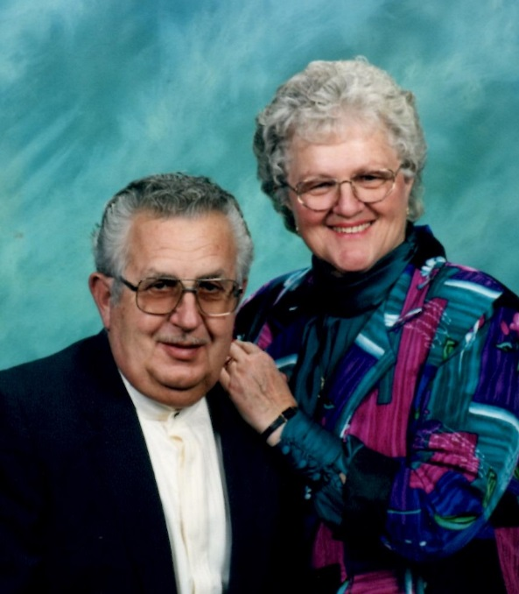
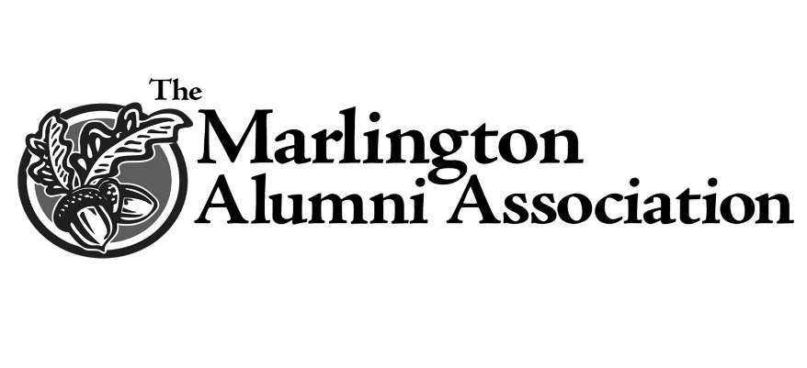
Richard W. and Annabelle M. Bohaychyk (Fearon) Memorial Scholarship
In 2003 the Bohaychyk family established a scholarship in memory of Richard W. Bohaychyk as a way to honor and remember this special man. His wife, Annabelle (Bloss) Bohaychyk graduated from the original Marlboro High School in 1954. Richard and Annabelle had five children, all of whom who all graduated from Marlington: Vondea (’76), Vanessa (’77), Crystal (’79), Nick (’81), and Scot (’82).
Although Mr. Bohaychyk never graduated from high school he was an accomplished machinist, electrician, and environmental engineer. He took many classes and achieved both academic excellence and professional recognition. While working at the Teledyne Monarch Rubber Co. in Hartville, Ohio he worked his way from stock boy to environmental engineer. This scholarship is to honor students who exemplify Mr. Bohaychyk’s love for tinkering and his enthusiasm for learning.
Annabelle passed away on Sunday, April 5, 2015 after a brief illness. She was a Marlington Alumni Association Board member for 17 years, beginning in 1998. Annabelle was recognized in 2001 as an Outstanding Alumna. She was a past president of the association and for decades played an active part in planning the Marlboro High School reunions.
Recipients of this award will share a love for learning and possess a motivation to overcome obstacles and a desire to give back to the community. Applicants for this scholarship may pursue a certificate program in any mechanical or technical field (small engine repair, diesel mechanics, machinist trade, etc.) an Associates (one or two-year) Degree or a certificate program of any kind. Preference will be given to the candidate with the greatest need.

