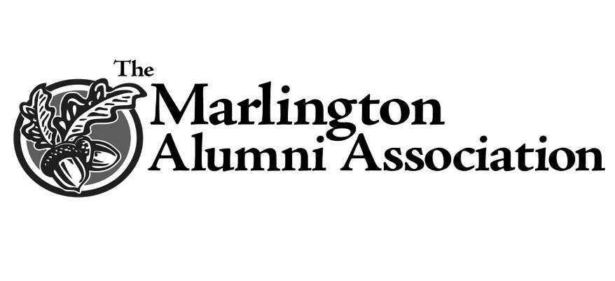
Gerald P. Burke Scholarship
Mr. Gerald “Jere” Burke devoted nearly 30 years of his professional life to teaching and working
in the Marlington Local School District. He and his wife, Mary Ann, raised four children – Greg
(a 1974 MHS graduate), Rick, Mike, and Susan – and were married for 53 years before his
passing in 2009.
A native of Youngstown, Ohio, and a graduate of Youngstown State University, Mr. Burke’s
contributions during his tenure at MHS went far beyond those in the classroom, where he mainly
taught English and Latin before finishing his career as head librarian. He served as the school’s athletic ticket manager for football and basketball for many years, was a class advisor on more than one occasion, coached speech and debate, spearheaded organization of the first prom in school history, and worked with the school’s Occupational Work Experience (OWE) program.
Mr. Burke also found time to become involved in his church and community. He and his wife were presented with an annual award for dedication and service to the Carnation City Festival and to the Alliance community. He was extremely active with St. Joseph’s Catholic Church, including serving as a marriage preparation mentor for 20 years. He was a fourth degree member of the Knights of Columbus.
Mr. Burke placed a high priority on higher education and sacrificed tremendously – working
additional jobs in the evenings and on the weekends – throughout his life to put his children in a
position to attend college. To that end, all four Burke children have earned at least an
undergraduate degree.
Because of Mr. Burke’s appreciation for higher education and his tremendous work ethic, his
family set up the “Gerald P. Burke Scholarship.” Future graduates will have the opportunity to
pursue their dreams because of this family’s generosity. Scholarships will be awarded to
qualified applicants who plan to pursue a course of study leading toward a Bachelor’s degree in
any field of study.

