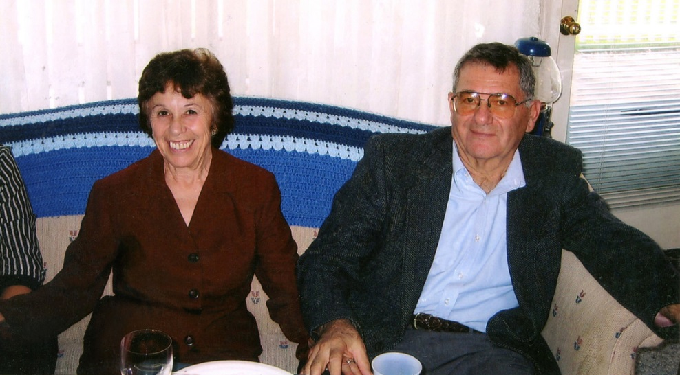
The Frank and Anna Carozzi Memorial Scholarship
Frank Carozzi (’83) and his sister Natalie (Carozzi) Mamlin ('84) and their spouses have honored their parents by funding The Frank and Anna Carozzi Memorial Scholarship.
The scholarship will be awarded to a student pursuing a career in education, accounting or finance, and with a preference for students attending an Ohio university.
Anna Bernadette Carozzi was born in Wellsville, Ohio, moving to Canton when she was in 2nd grade, graduating from Canton McKinley High School. She served in the United States Marine Corp at bases in San Francisco and Hawaii. On June 15, 1963, a year after her discharge, she married Frank Carozzi. Anna felt that her most important role and biggest accomplishment was that of mother to her two children. She is remembered for her boundless energy, optimism, honesty and complete love of life.
Anna was preceded in death by her husband, Frank, who passed away on August 4, 2005. He graduated from Canton McKinley High School and The Ohio State University. He also proudly served his Country for two years with the U.S. Army in Germany. He was a restaurant owner for over 30 years and a school teacher for 25 years in the North Canton School District. Frank enjoyed working on building projects of his own and those of his friends, being self-taught in all aspects of construction. He was also an avid golfer.

