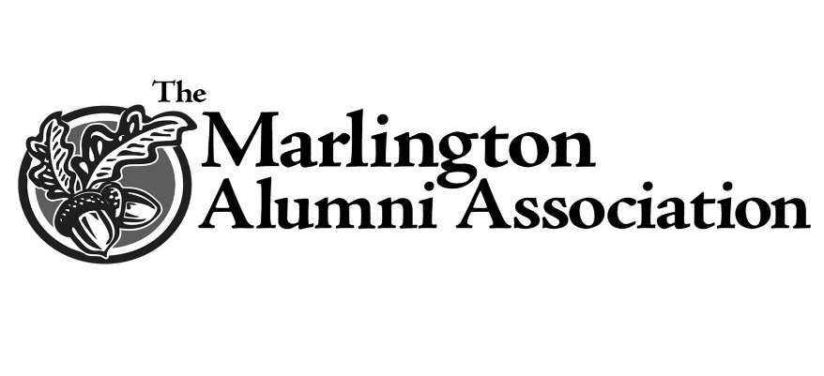
The General John Churchill, First Duke of Marlborough
Academic Warrior Award
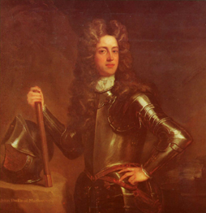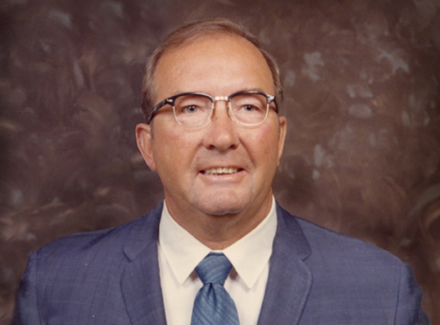

The Fred W. Elsass Fund was created in 2013 by Frederick L. Elsass (‘59) and his wife, Jill, to provide an annual academic achievement award to a senior Marlington football player and to show their great love and admiration for their father. It is titled The General John Churchill, First Duke of Marlborough, Academic Warrior Award honoring two men who led challenging lives, fought many battles and had significant achievements.
Frederick (Fred) W. Elsass (December 12, 1916 – June 27, 2008) was born on a farm in Stark County, the sixth child in a family of nine. He adored his mother and loved and feared his father. At birth his eyesight was damaged by a well-meaning midwife. Growing up, he and his three younger sisters attended a one room school, though Elsass left after the eighth grade. Both events had a profound effect on him all his life.
Elsass worked on the family farm until it was sold, then moved to Canton and worked in the muck of Meyers Lake with his grandfather, Jacob, a German immigrant. It was his father and grandfather who instilled a work ethic in Elsass that was without equal. He raised vegetables to support his family during the depression until his first ‘real’ job with the Canton Park Department. Over the years he worked as a Security Guard, Deputy Sheriff, Detective, Detective Sergeant, Juvenile Probation Officer, Adult Probation Officer and finally as the Superintendent of the Canton City Park Department. The parks he built are a lasting legacy.
He raised four sons, two of whom are graduates of Marlington High School. He moved to Marlboro Township in 1953 where he lived until his death in 2008. He loved all sports, loved to hunt, sing, dance and play several musical instruments. He was very active in his church and was a 32nd Degree Mason, but was always particularly proud when he earned his high school diploma, July 19, 1964, at the age of forty-eight.
John Churchill (May 26, 1650 – June 16, 1722) was a brilliant British military officer. His family was left destitute after the English Civil War when his father fought on the side of the crown. He was taken in by his grandmother, Lady Eleanor Drake (who had supported Parliament and Oliver Cromwell) and was educated at the Dublin Free School and St. Paul’s School in London. He was appointed to be a page to James, Duke of York in 1665, a turning point in his life.
James exposed him to Army and Navy matters which developed a passion in the young Churchill. He was commissioned as an Ensign into the Kings Own Company, 1st Guards on September 14, 1667, and his rise in rank was astounding. Because of his professionalism and heroics, he assumed the grade of Lt. General in 1688. In 1702 he was named Captain General of the Armies and Master-General of the Ordnance by Queen Anne and became The Duke of Marlborough. (This same region
is the namesake of Marlboro Township.)
During the War of Spanish Succession Churchill defeated the armies of Louis XIV in the battles of Blenheim, Ramillies, Oudenarde and Malplaquet. (1704- 1709) He returned to England a hero and was rewarded by Queen Anne and Parliament with sufficient funds to build Blenheim Palace. Blenheim Palace was built to rival the Palace of Versailles, home of the vanquished King Louis XIV, and will serve as Churchill’s legacy- a place for generations to visit and appreciate forever.
“A hundred thousand words would not be sufficient to convey how we feel about
these two men.” Frederick L. and Jill Elsass

