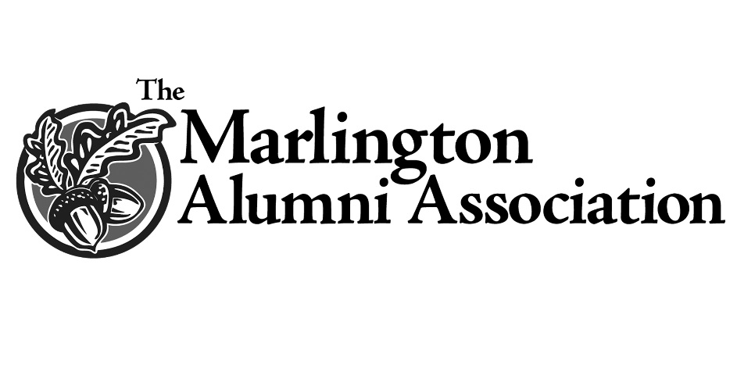
Class of ’68 Scholarship

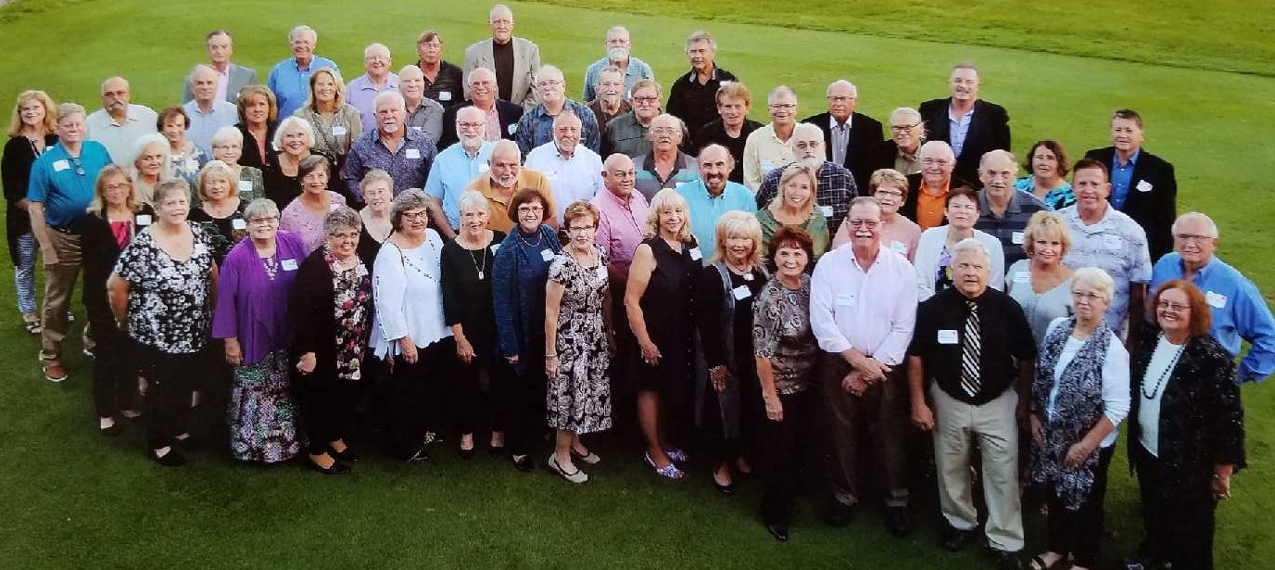

When friends and classmates from the class of 1968 gathered in 2018 for their 50th reunion, they reminisced about good times and friendships they’ve maintained. They also discussed ways they could collectively impact the future.
Under the leadership of classmates Jerry Peterson (’68), Dr. Tom Robinson (’68) and Clyde Lepley (’68), the group knew they wanted to create a legacy that would pay tribute to classmates they have lost over the years. They also wanted to recognize the solid education they received at Marlington. Establishing a scholarship with the MAA, they determined, was the best way to accomplish both.
The Class of 1968 Scholarship was awarded for the first time in April, 2019 and will provide academic assistance to students pursuing any degree program.

