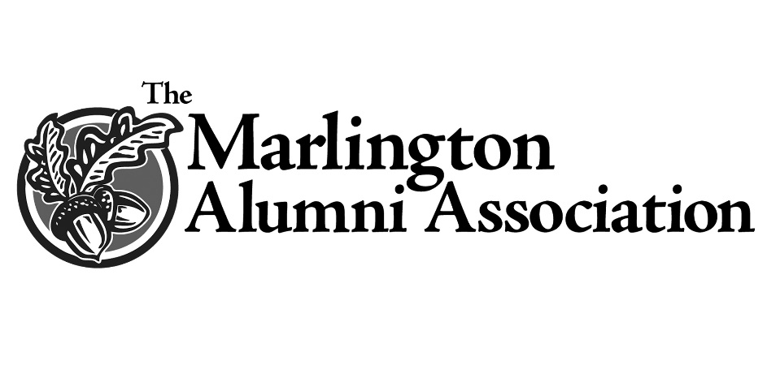
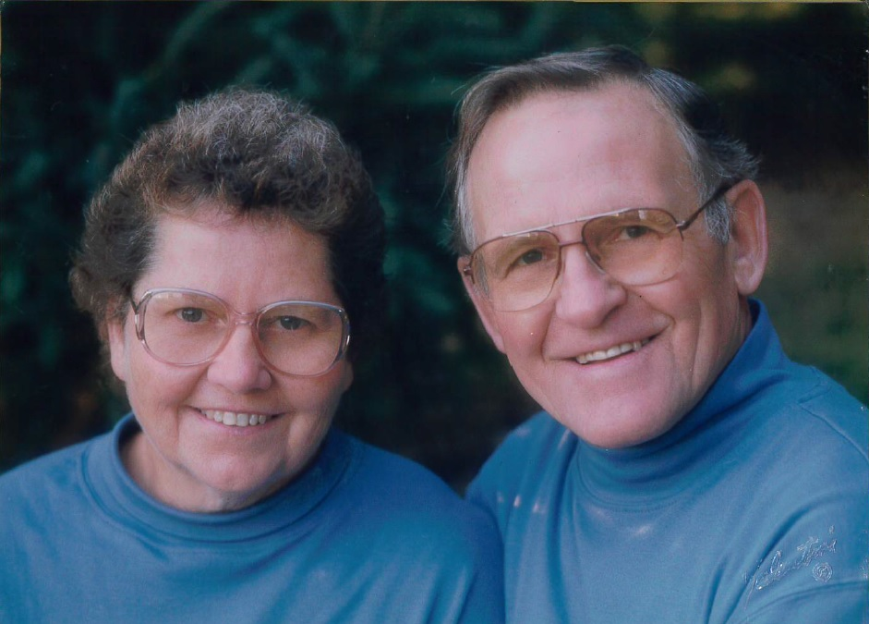
Howard and Ruthann Dickerhoof Scholarship
The MAA is pleased to partner with the Dickerhoof family to honor the memory of their beloved parents, Howard and Ruthann Dickerhoof.
Howard was a graduate of Timken High School, then served his country in the United States Army during the Korean conflict. He was then employed as a plumber, retiring from Doerschuk Plumbing after 42 years. He was a member of the Washington Ruritans Club and the Plumbers Local No. 94.
Ruthann was a graduate of Canton South High School and the Aultman School of Nursing. She worked for 29 years as a Registered Nurse for Marlington Local Schools. For 29 years she served as an Advisor for the Washington Twp. 4-H Club, and was an Aultman Nursing Association Alumnae. The couple were longtime members of The Chapel in Marlboro.
Ruth Ann Dickerhoof died September 10, 2006 at the age of 73. Howard died December 11, 2018 at the age of 88.
Known for their love of family and exuberance for life, this award will forever remember the Dickerhoofs and their impact on the community. Their children Mark (‘74), twin sons, Brad and Bruce, (‘80) and daughter, Martha (Dickerhoof) Palmer (‘77) are pleased to remember their parents with this special award.

