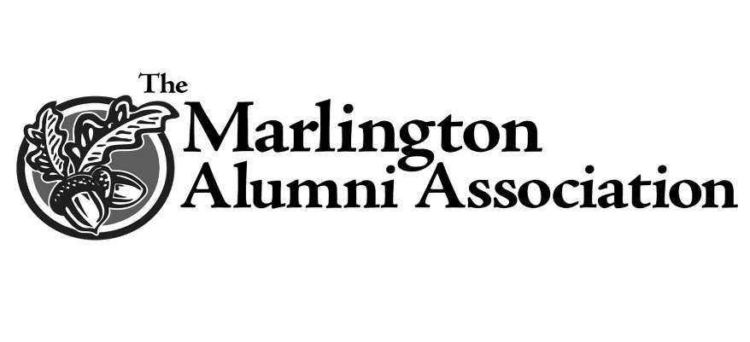
Hastings Scholarship  The Hastings Scholarship was created to assist students interested a career in journalism or science.  James (’53) earned a Bachelor of Arts in Journalism and a Masters in Public Relations and Industrial Communications from Kent State University. Erma earned a Bachelor of Science in  Medical Technology also from Kent State University.  Jim was the editor of the Alliance Review from 1976 to 1997. Erma worked in the laboratories of both Akron General Medical Center and the Alliance Community Hospital. Their children,  Michael (’80), Douglas (’82), and Sharon (Hastings) Zurbrugg (‘84) are also Marlington graduates. Scholarships will be awarded to qualified applicants who choose to pursue a course of study leading toward a Bachelor’s degree in either Journalism or Science. | 