Howard F. and Trudy S. Kitzmiller Student Athlete Award

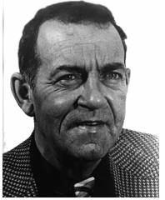
The Howard F. and Trudy S. Kitzmiller Student Athlete Award was fondly established by Marlington alum and track great, Steve Miller (’78) to honor the life and legacy of one of Marlington’s most respected and influential basketball and track coaches. Under “Kitzy’s” leadership, Marlington won multiple Federal League championships in basketball, track and cross country. The scholarship will initially be awarded to top male or female track members. However, after the endowment surpasses $25,000, top basketball athletes will also be included.

Kitzmiller whose passing in 1978 was mourned by the community, coached basketball, track and cross country at Marlington during his 13 year tenure. He was decorated with a Purple Heart for his service in WWII and inducted into the Basketball Hall of Fame, but was most loved for his impact on the lives of Marlington students. The cover of the 1978 Marlington Spring Sports Banquet program, dedicated in his memory, articulated the sentiments of the hundreds of students he influenced. "To be remembered for the many pleasant victories and for the great performances of so many fine athletes - of course we shall remember. But when memories fade with time, coach Kitzy's influence as a man will continue with us and with those to come. For he has proven to be a man of loyalty and integrity, a man of courage when faced with adversity, and a man of humility when visited with success , a Christian gentleman."

