James Krabill Memorial Scholarship
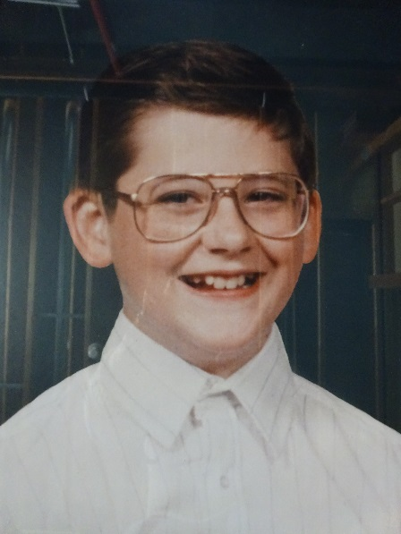
The James Krabill Memorial Scholarship was established by Lyle and Margaret Krabill following the untimely death of their 5th grade son, Jimmy, on October 25, 1993.

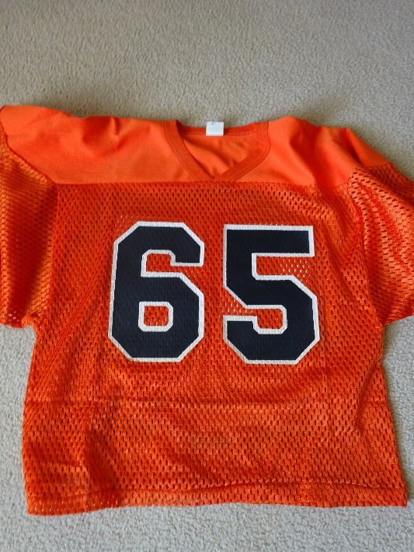
Jimmy was ten years old and a student at Marlboro Elementary when he was struck and killed while riding his bicycle. He was a very willing and hard worker on the family farm. In his spare time he spent many hours reading and was particularly fond of Hardy Boys mysteries and super-hero comics. Jimmy was a junior varsity football player for the Little Dukes. His number 65 jersey was retired in his memory.

Members of the farming community all their lives, the Krabill’s chose to honor their son’s memory with a scholarship benefitting students who choose to pursue a career in Agriculture, Horticulture or a related field.

From a devastating tragedy and because of the generosity of this family, this scholarship has awarded more than $100,000 in scholarships to Marlington students.

