Lexington Twp. Vol. Firefighter Scholarship
in Memory of Berkley Barker

Reliable, generous and committed. When Lexington Township’s residents remember Berkley Barker, those are the words that often come to mind. In times of crisis, trauma or disaster, he was respected for his common sense and ability to make wise decisions quickly. In the community he was appreciated as a businessman, and admired as a Charter member of the Lexington Fire Department. And as one of eleven children, Berk was known for his work ethic and generosity to others.
It was for those same reasons that colleagues from the Lexington Township Fire Department chose to partner with the Marlington Alumni Association to honor the memory of their friend by establishing the Berkely Barker Memorial Scholarship. This scholarship goes to a Marlington student pursuing further education in fire science, emergency medical service, nursing, police training or any related career.
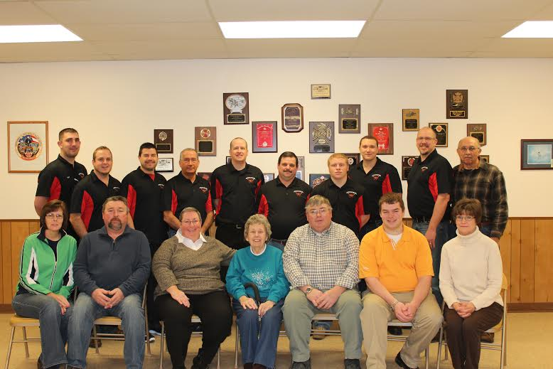

“I have no ambition in this world but one, and that is to be a fireman. The position may, in the eyes of some, appear to be a lowly one; but we who know the work which the fireman has to do believe that his is a noble calling. Our proudest moment is to save lives.” Edward F. Croker

