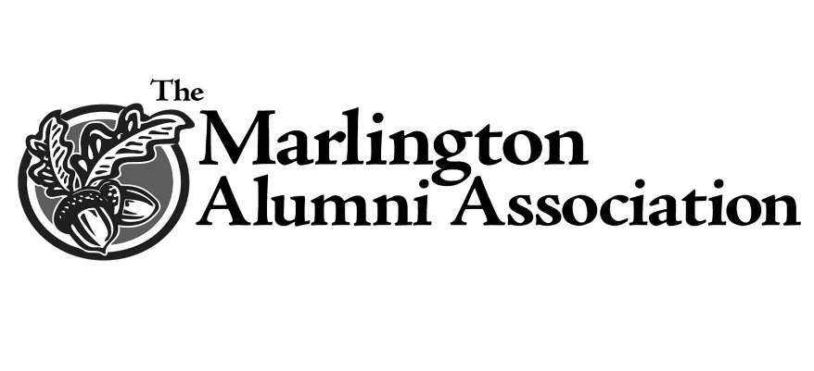

Marlington Alumni Association – Duke Scholarship
In addition to scholarships established by the many generous friends and families associated with Marlington, the MAA is pleased to provide additional scholarships supported completely by our alumni and friends.
It is our desire to continue to encourage diligent and hard-working students by providing the financial support- and vote of confidence- to outstanding Marlington Seniors.
A special award selected by the MAA Scholarship committee, the Marlington Duke Scholarship, is awarded to a student who has shown extra effort and commitment.

