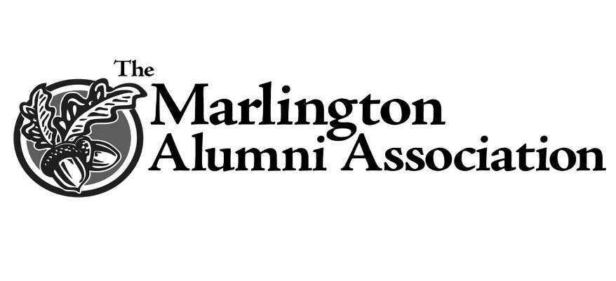

Marlington Alumni Association Scholarship
In addition to scholarships established by the many generous friends and families associated with Marlington, the MAA is pleased to provide additional scholarships supported completely by our alumni and friends.
It is our desire to continue to encourage diligent and hard-working students by providing the financial support- and vote of confidence- to outstanding Marlington Seniors.
These awards are made to top performing academic students who also exemplify strong character, integrity and characteristics that will make our alumni proud!

