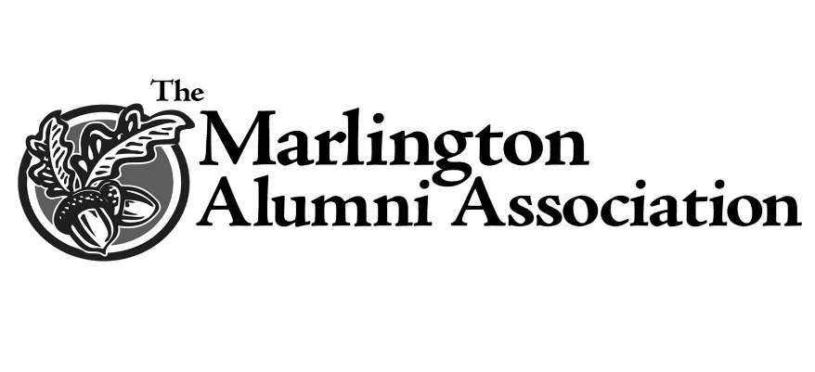

Wayne and Bertha McAlister Family Scholarship

Wayne (’37) and Bertha McAlister believed in young people and in their education. Following
his death, Mrs. McAlister established this scholarship to provide opportunities for deserving
Marlington graduates. Their children Sandra (McAlister) Binius (’70), Janet (McAlister)
McCallin (‘71) and Gloria McAlister (’74) are Marlington graduates and pleased to honor their parents’ memory.

Scholarships will be awarded to qualified applicants who pursue a course of study leading
toward a Bachelor’s degree in their chosen field of interest.

