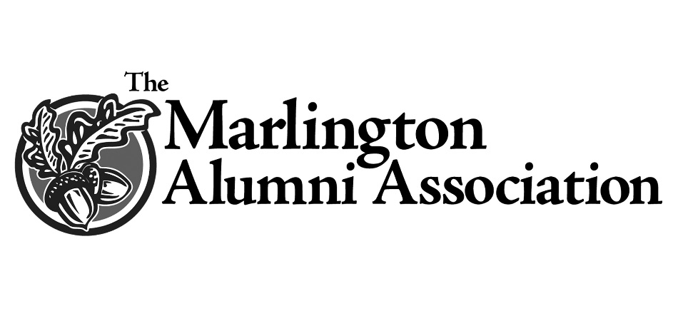
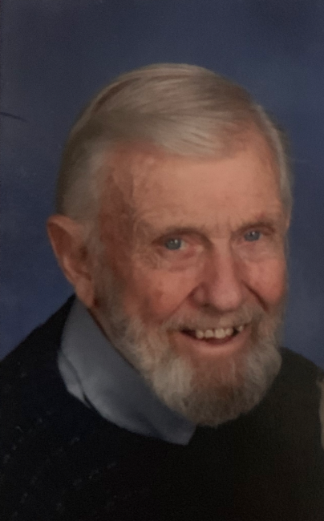
Donald D. Moore Memorial Scholarship
The Marlington Alumni Association (MAA) is pleased to partner with the Moore family to honor the memory of a man who was a quiet blessing and inspiration to many.
Donald Dewey Moore was a 1945 graduate of Marlboro High School and served his country in the United States Navy. He and his wife, Betty Enoch (’50), married in 1950 and lived most of their lives in New Baltimore, Ohio.
The Moore family shares a rich and treasured legacy within the Marlington district. Don’s siblings Dorothy (Moore) Conner (’44), John Moore (’47), Mary (Moore) Psolla (’52), Martha (Moore) Cornette (’54) were all graduates of Marlboro High School. Don and Betty’s children, Dr. Janice (Moore) Spalding (’68), Deborah (Moore) Hess (’70), Dr. Kim J. Moore (’73), and Kristine (Moore) Yavelak (’76), are also all graduates of Marlington High School.
People who knew Donald remember him for his strong faith, his love for his family and friends, and his service to the community. His work in building the New Baltimore Community Park continues to be a blessing to families, providing a safe place for children to swing and play ball. Moore also dug graves at Marlboro Cemetery for more than 40 years.
He gifted many people with his masterful carpentry and woodworking skills. His many hobbies included golfing, bowling, singing in the choir and men's groups, and taking many memorable motorcycle trips with good friends, the Pontius's.
His wife, sisters Mary and Martha, children, and their families, including 13 grandchildren and 16 great-grandchildren, are honored to remember Don Moore with this special award. This award will support students pursuing a variety of careers, including science, engineering, medicine or tech/trade.

