Austin “Pete” Moulin Scholarship
Austin “Pete” Moulin was born in 1917. He attended Science Hill, a one room school, through 3rd grade, and later attended Sacred Heart Elementary and Louisville High School.
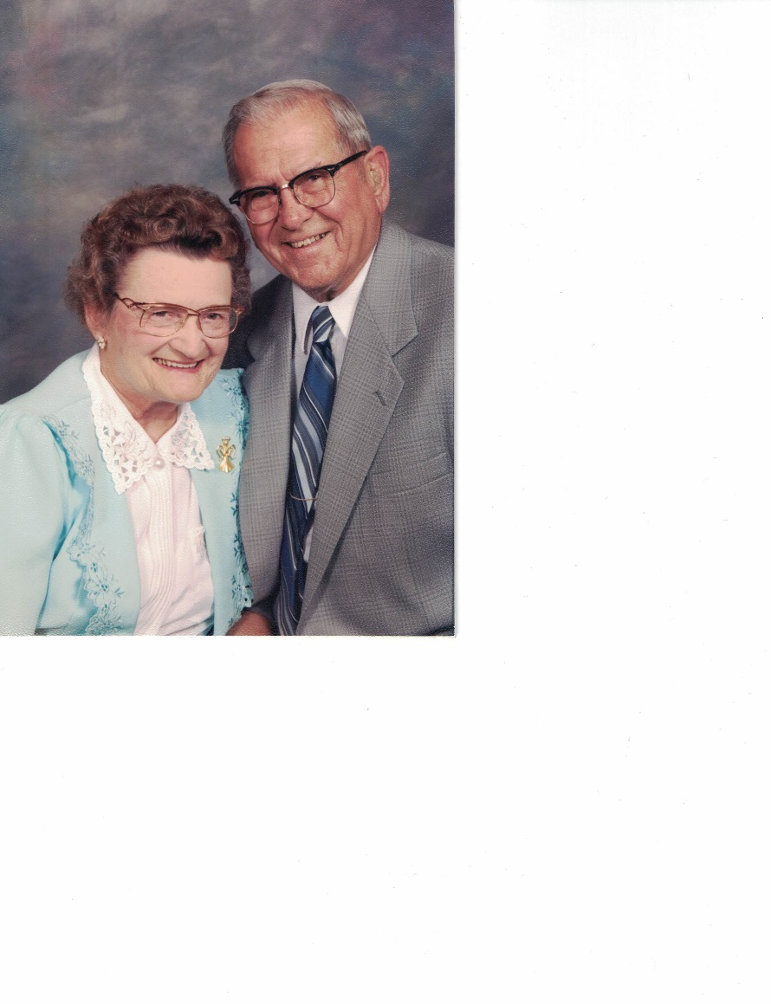
He was employed at Alliance Manufacturing for 26 years and with the help of his wife, Rita they managed a dairy farm. In 1957 Moulin converted the farm’s chicken house and began what grew into the thriving business of Moulin Products, a local manufacturing company.
Over the years Pete and Rita were active in their church, Sacred Heart of Mary. Pete lovingly sponsored a Habitat for Humanity home in Rita’s honor. The Moulin’s generously donated time and resources, establishing what we now know as the Moulin Center, Marlington’s indoor athletic facility, and scholarships named in honor of both Pete and Rita. Their children, Trudy and Richard, are pleased to remember their parent’s legacy with this annual scholarship.

