Rita Moulin Scholarship
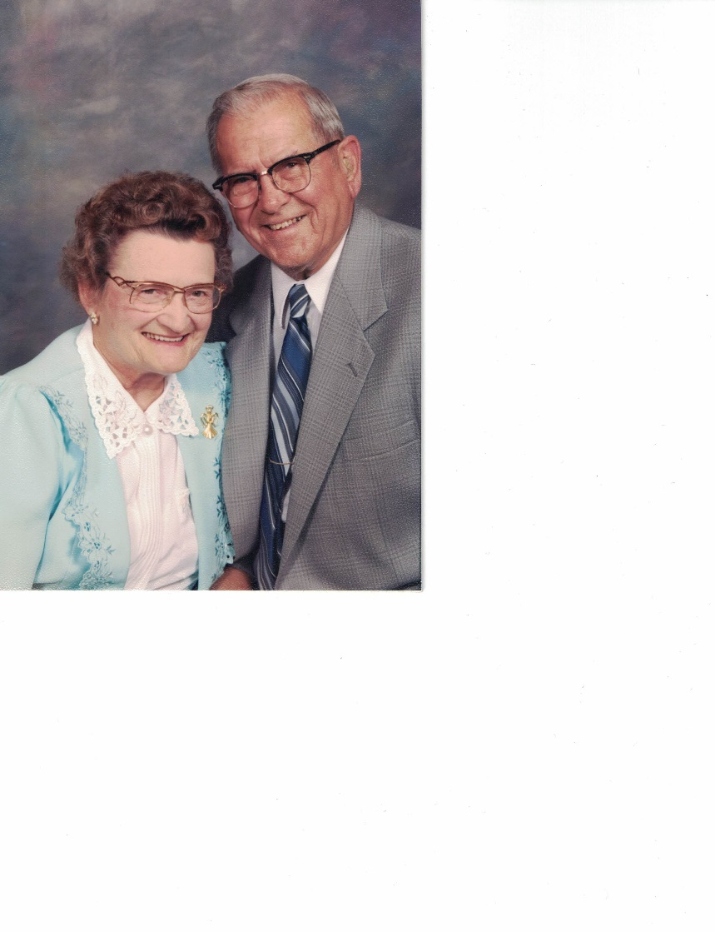
Through a generous family gift, the Rita Moulin Scholarship was established to encourage and affirm a deserving Marlington senior.
Rita (Schwallie) Moulin was born in 1919 and grew up in Louisville, Ohio. She assisted in the daily functions of the family’s poultry and dairy farm and played an essential role in the opening of Moulin Products in 1957. Not only was she co-owner of the family business, but she was also secretary, troubleshooter and occasional laborer in the manufacturing plant.
Rita was an excellent cook, enjoyed bowling, golf, quilting and travel. She was a devoted wife, married to Pete nearly 59 years, and loving mother to their children Trudy and Richard.

