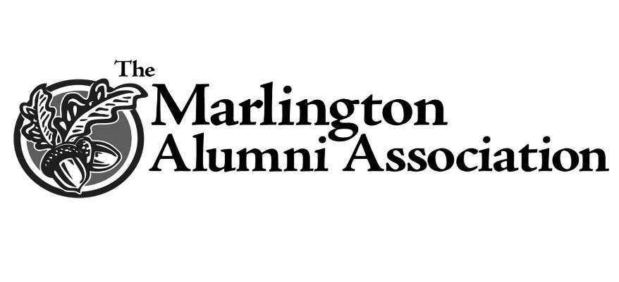

Franklin L. (Butch) Muniz Scholarship
The Franklin L. (Butch) Muniz Scholarship was established in 2013 by the friends and family of Mr. Muniz to recognize the accomplishments of students who have excelled in both academics and baseball at Marlington High School.

With a belief in the value of hard work, faith, persistence, determination and in support of strong academics, the Butch Muniz family is honored to provide assistance to Marlington’s top baseball athletes.

Butch was passionate about baseball and never missed an opportunity to see his grandson play. Sadly, Butch passed too soon and was not there to see his grandson play his last few years of high school ball at Marlington. With a love of the game and a greater love of people, his enduring smile and name will live on through this scholarship award.

