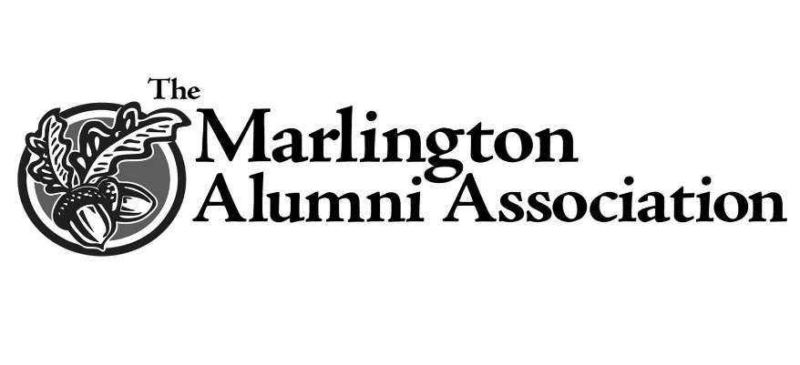

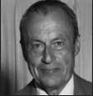
Melvin J. Snode Memorial Scholarship
Affirming his parents dedicated value of education, Melvin Snode walked to one-room schools and Alliance High School after completing his morning farm chores. Also, this life-long area resident remarkably never missed a day of school.
Melvin's post public school education was at Mount Union College and Kent State University, which was interrupted by service in Germany during the Second World War. Evidence of his value for education was his university enrollment in Great Britain and Switzerland at war's end.
Returning stateside with his early prewar experience as a teacher at Fairmount Children's Home, and later Middlebranch and Glenwood High Schools under his belt, Snode accepted a position at the newly built Marlington High School filling the guidance counselor role, his first love for the next 22 years. Guidance afforded him the opportunity to counsel a greater number of young people and steer them in the direction of balancing the mental, physical, spiritual and social facets of life.
It was many of his former students' expressed appreciation for his making a difference in their lives that affirmed he had indeed made the correct career choice. Chances are some of those same students are with us here tonight.
Melvin was not the only Snode family member to make Marlington his institution of learning. All of his seven children and stepchildren plus five of his grandchildren graduated from Marlington High School. Retirement from education did not slow him down. He continued his Marlington involvement as boys’ basketball scorekeeper, 30 years at the table; and enjoyed countless hours as co-owner of Tannenhauf, the family golf course.
Appreciating a school's excellence and devotion to educating and enriching students' lives is why Melvin held the highest regard for Marlington and The University of Mount Union. Not surprisingly, three of his Marlington children and one grandchild followed him to Mount.
It is his family's desire for The Melvin J. Snode Memorial Scholarship to stand as a tribute to the educational values that Melvin's parents so instilled in him, and with great hope those same beliefs will pass on to future Mount Union scholars.

