Harold (Hal) and Ruth Sweitzer Scholarship
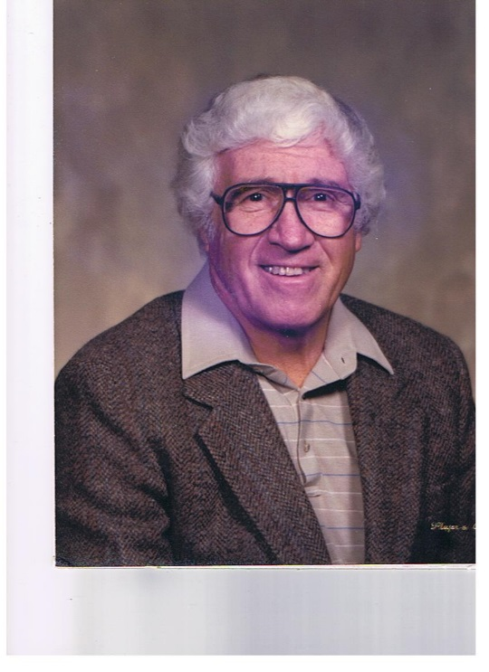

A generous gift honoring Ruth (Smith) Sweitzer (’39) and the late Harold (Hal) Sweitzer (’34) established the Harold (Hal) and Ruth Sweitzer Scholarship to benefit students pursuing a degree in any Art or Music. Following Hal’s death Ruth wanted to create a legacy to honor her husband’s memory. Hal graduated from the former Marlboro High School in 1934 and was manager of the former Sweitzer China Company.

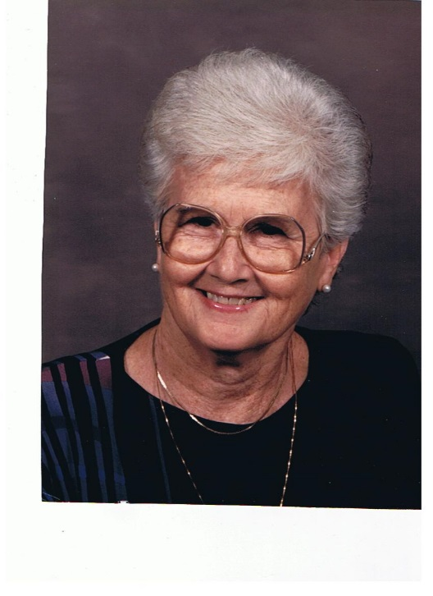
In 1956, at the age of 40, he became interested in oil painting and painted landscapes and seascapes. He demonstrated and exhibited his work in Ohio and Pennsylvania for many years and taught art classes at the Alliance Art Center at Mt. Union College and in his home.

